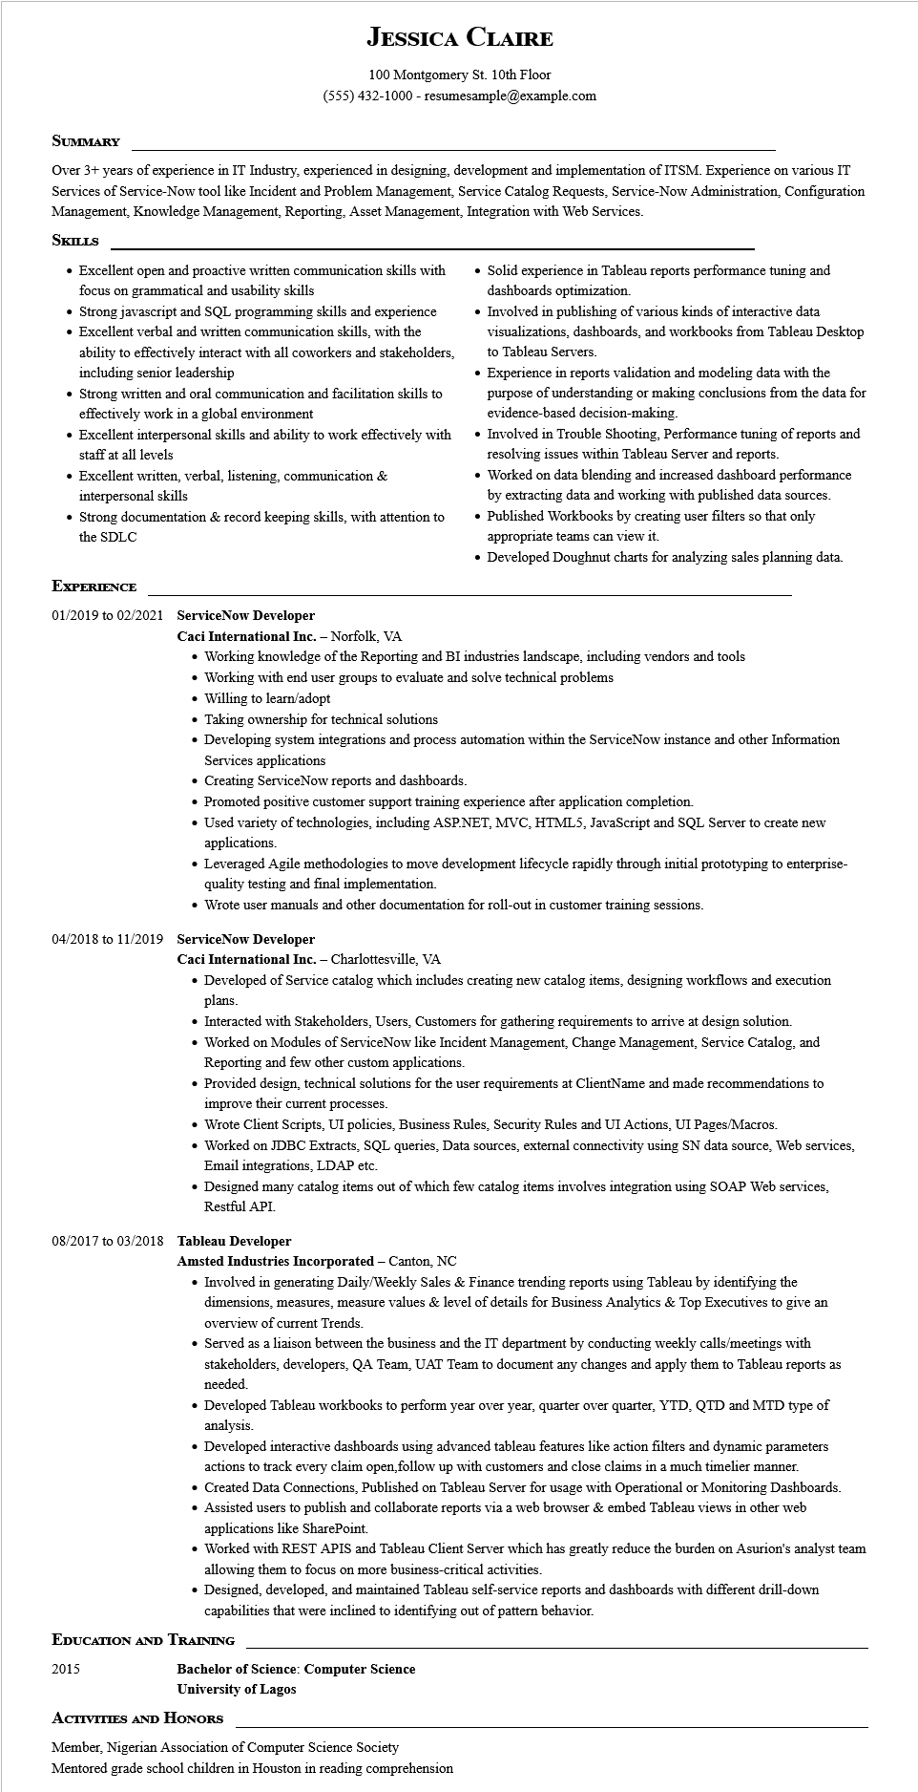
JESSICA CLAIRE
100 Montgomery St. 10th Floor
(555) 432-1000 - resumesample@example.com
SUMMARY
Over 3+ years of experience in IT Industry, experienced in designing, development and implementation of ITSM. Experience on various IT Services of Service-Now tool like Incident and Problem Management, Service Catalog Requests, Service-Now Administration, Configuration Management, Knowledge Management, Reporting, Asset Management, Integration with Web Services.
SKILLS
• Excellent open and proactive written communication skills with focus on grammatical and usability skills
• Strong javascript and SQL programming skills and experience
• Excellent verbal and written communication skills, with the ability to effectively interact with all coworkers and stakeholders, including senior leadership
• Strong written and oral communication and facilitation skills to effectively work in a global environment
• Excellent interpersonal skills and ability to work effectively with staff at all levels
• Excellent written, verbal, listening, communication & interpersonal skills
• Strong documentation & record keeping skills, with attention to the SDLC
• Solid experience in Tableau reports performance tuning and dashboards optimization.
• Involved in publishing of various kinds of interactive data visualizations, dashboards, and workbooks from Tableau Desktop to Tableau Servers.
• Experience in reports validation and modeling data with the purpose of understanding or making conclusions from the data for evidence-based decision-making.
• Involved in Trouble Shooting, Performance tuning of reports and resolving issues within Tableau Server and reports.
• Worked on data blending and increased dashboard performance by extracting data and working with published data sources.
• Published Workbooks by creating user filters so that only appropriate teams can view it.
• Developed Doughnut charts for analyzing sales planning data.
EXPERIENCE
01/2019 to 02/2021 ServiceNow Developer
Caci International Inc. - Norfolk, VA
• Working knowledge of the Reporting and BI industries landscape, including vendors and tools
• Working with end user groups to evaluate and solve technical problems
• Willing to learn/adopt
• Taking ownership for technical solutions
• Developing system integrations and process automation within the ServiceNow instance and other Information Services applications
• Creating ServiceNow reports and dashboards.
• Promoted positive customer support training experience after application completion.
• Used variety of technologies, including ASP.NET, MVC, HTML5, JavaScript and SQL Server to create new applications.
• Leveraged Agile methodologies to move development lifecycle rapidly through initial prototyping to enterprise- quality testing and final implementation.
• Wrote user manuals and other documentation for roll-out in customer training sessions.
04/2018 to 11/2019 ServiceNow Developer
Caci International Inc. - Charlottesville, VA
• Developed of Service catalog which includes creating new catalog items, designing workflows and execution plans.
• Interacted with Stakeholders, Users, Customers for gathering requirements to arrive at design solution.
• Worked on Modules of ServiceNow like Incident Management, Change Management, Service Catalog, and Reporting and few other custom applications.
• Provided design, technical solutions for the user requirements at ClientName and made recommendations to improve their current processes.
• Wrote Client Scripts, UI policies, Business Rules, Security Rules and UI Actions, UI Pages/Macros.
• Worked on JDBC Extracts, SQL queries, Data sources, external connectivity using SN data source, Web services, Email integrations, LDAP etc.
• Designed many catalog items out of which few catalog items involves integration using SOAP Web services, Restful API.
08/2017 to 03/2018 Tableau Developer
Amsted Industries Incorporated - Canton, NC
• Involved in generating Daily/Weekly Sales & Finance trending reports using Tableau by identifying the dimensions, measures, measure values & level of details for Business Analytics & Top Executives to give an overview of current Trends.
• Served as a liaison between the business and the IT department by conducting weekly calls/meetings with stakeholders, developers, QA Team, UAT Team to document any changes and apply them to Tableau reports as needed.
• Developed Tableau workbooks to perform year over year, quarter over quarter, YTD, QTD and MTD type of analysis.
• Developed interactive dashboards using advanced tableau features like action filters and dynamic parameters actions to track every claim open, follow up with customers and close claims in a much timelier manner.
• Created Data Connections, Published on Tableau Server for usage with Operational or Monitoring Dashboards. • Assisted users to publish and collaborate reports via a web browser & embed Tableau views in other web applications like SharePoint.
• Worked with REST APIS and Tableau Client Server which has greatly reduce the burden on Asurion's analyst team allowing them to focus on more business-critical activities.
• Designed, developed, and maintained Tableau self-service reports and dashboards with different drill-down capabilities that were inclined to identifying out of pattern behavior.
EDUCATION AND TRAINING
2015
Bachelor of Science: Computer Science
University of Lagos
ACTIVITIES AND HONORS
Member, Nigerian Association of Computer Science Society
Mentored grade school children in Houston in reading comprehension

